What is an Amazon EBS Volume?

* Elastic Block Store volume is a **block level storage device** that can be associated with an EC2 instance
* EBS Volumes can be used as both **primary storage** and **secondary storage**
* The **primary EBS volume** acts as **root volume** and should be created and attached to the **instance at the time of instance launch.**Storage can be increased in the future if needed. This primary EBS volume cannot be detached from the instance.
* The **secondary volume** can be **attached, detached and modified at any time.**
* An **instance** can have **one primary EBS** volume and **n number of secondary volumes**
* **One EBS Volume** can be only associated with **one instance**
* There are 5 types of EBS volumes:
  + **General Purpose SSD (gp2)**- Provides **balance of both price and performance** and is generally chosen by default
  + **Provisioned IOPS SSD (io1)**-- Most expensive of the volume types with **highest performance** and well-suited for tasks with **heavy workloads**
  + **Throughput Optimized HDD (st1)**- A low-cost volume that focuses on optimizing throughput and is generally used for**large sequential workloads** dealing with big data warehouses. These volumes**cannot be used as root volumes** for EC2 instances.
  + **Cold HDD (sc1)**- least expensive of the volume types and specifically designed for **workloads** which are **accessed less frequently.**These volumes also**cannot be used as root volumes** for EC2 instances.
  + Magnetic (Standard) Previous generation magnetic volumes which **cannot be used as root volumes** for EC2 instances

## Advantages of using EBS Volumes

* **High availability** and **flexibility**
* **Data** can be kept **persistently on a file system** even after shut downing the instance
* Enables **snapshots,** which capture the data stored at a point in time and can be restored at any time.
* The snapshots enables us to **create a volume and attach it** to another instance if needed.
* Can be**resized** at any time as and when required
* Comes equipped with encryption (and encryption-at-rest).
* EBS Volumes can be **attached, detached and associated** with other instances at any point in time (exception the primary volume)

**Exercise:**

## Step 1 : Launch instance

**Step 2 : Resizing the EBS Volumes (**select **EC2 instance** andnavigate to the **Storage** tab and then click on **Volume id**present & Select the **Volume** and then go to the Actions menu dropdown. Click on **Modify Volume**)

## Step 3 : Give Volume Size you need to increase to and also note that we are not able to decrease the volume size. In our case, I’m modifying from 8GB to 30GB and then clicking on Modify.

**Step 4:** After modifying the volume, we need to **increase the partition**and**file system.** For that we have to login into server (EC2-Instance).

**Step5 :** Run below commands

sudo su

df –kh

lsblk

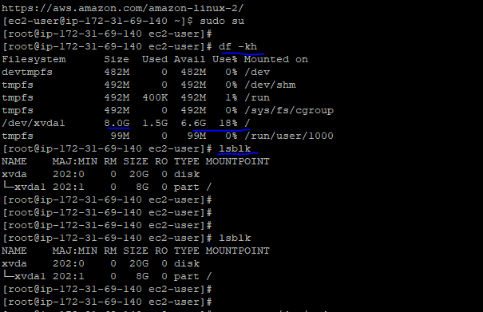

Extend the size by using the following command:

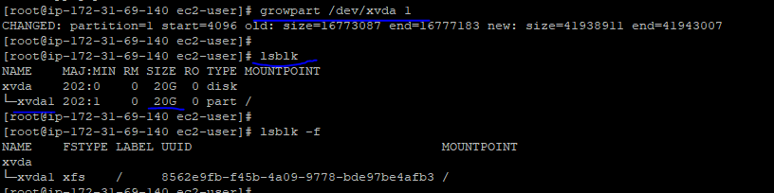

The above command will provide us the**file system** of the block devices which will be one among the following types:**ext2,ext3,ext4 or XFS**

Our file system is  **XFS: so we will use xfs_growfs /filesystem name , IF (ext2,ext3,ext4 the use -🡪 resize2fs /dev/xvda1)**

**Now by using df –kh you can check , changed block volume.**

## 